Associate Product Manager Case Study:
Shift Offers Analysis
RASHAAD AHMAD - June 29th, 2025

Executive Summary
This analysis dives into Clipboard Health's shift offer data to uncover what truly drives shift claim rates. My most significant finding is posting lead time (the time between when a shift was first viewed and its start date and time) directly impacts how likely a shift is to be claimed. Shifts posted closer to their start date see much higher claim rates. One possible reason for this is that workers prefer to claim shifts when they are more confident they will be available to work it and not have to deal with canceling it later or not showing up. Depending on how the user interface is designed, older postings might get buried under a flood of newer shifts in the app feed. This could be a game-changer for how healthcare facilities post shifts and can significantly improve our marketplace's efficiency by ensuring more shifts get filled for healthcare facilities and increased revenue for us.

Introduction & Approach
Clipboard Health is a two-sided marketplace, connecting healthcare facilities needing staff with professionals seeking flexible work. A core challenge for us is optimizing shift offers to boost claim rates, ensuring facilities are always staffed and workers find the shifts they want.
My goal was to dig deep into shift offer data to uncover signals that could guide product strategy and improve marketplace performance. I started by cleaning and preparing the raw data, ensuring its accuracy and focusing on the most relevant transactions. Then, I jumped into exploratory data analysis to spot initial patterns and distributions. My deeper dives tested several hypotheses, looking at factors like pay rates, shift durations, time-of-day, and, posting lead time. I used Python with Pandas and Matplotlib for all data manipulation, calculations, and visualizations.
Crucial Assumptions Guiding My Analysis:
- Each data row accurately represents a different shift offer viewed by a specific worker.
- For unclaimed shifts, I calculated potential profit based on the highest RATE offered so I could make a conservative estimate of potential earnings.
- My data cleaning focused on two different shift outcomes: shifts successfully worked by the first person who claimed it, and shifts that were never claimed at all. This let me focus on shifts where workers demonstrated a clear intent to work (by completing the shift later on) versus shifts where no worker had any intention to work that shift because they never claimed it
- I treated rate and charge_rate as straightforward hourly figures for workers and facilities, and assumed no hidden fees or other variables skewed these values.

Data Exploration & Initial Observations
Our dataset details individual shift offers, with each row marking a unique instance of a worker viewing an offer. Key information includes the SHIFT_ID, WORKER_ID, WORKPLACE_ID, SHIFT_START_AT, OFFER_VIEWED_AT, RATE (worker pay per hour), CHARGE_RATE (facility bill rate per hour), DURATION, and other shift status indicators like CLAIMED_AT, CANCELED_AT, DELETED_AT, IS_NCNS, and IS_VERIFIED.
Understanding Our Marketplace Dynamics:
- One shift can generate multiple offers, each seen by different workers at potentially different pay rates.
- An offer is either claimed or ignored.
- Even if claimed, shifts can later be canceled by workers or deleted by facilities.
To zero in on the initial claim decision, I filtered out shifts affected by cancellations, no-call-no-shows (IS_NCNS), or unverified claims (IS_VERIFIED). This meant removing views for SHIFT_ID’s where:
- A CANCELED_AT timestamp was logged.
- The worker was a no show (IS_NCNS == TRUE).
- The first claimer wasn't verified (IS_VERIFIED == FALSE).
This process removed 518 unique shift IDs, leaving a solid dataset of 19,382 unique shifts. Of these, 12,284 shifts were successfully claimed and completed, while 7,098 shifts were never claimed. This cleaning ensures my analysis focuses on clear outcomes, free from post-claim complications. I also created a new column called SHIFT_END_AT which was calculated by using SHIFT_START_AT + DURATION. This will help later with time analysis of shifts.
During my initial exploration, I created a simple bar chart comparing the profits collected on claimed shifts versus the potential profits lost on unclaimed shifts within the dataset’s time frame (July 29, 2024, to January 21, 2025).
For claimed shifts, I calculated total profit using the formula:
[(CHARGE_RATE – RATE) * DURATION]
(This also accounted for any shifts that were claimed at a RATE above the CHARGE_RATE.)
For unclaimed shifts, I estimated the potential profits lost with a conservative approach:
[(CHARGE_RATE – (highest payrate offer made)) * DURATION]
This method reflects what Clipboard Health was willing to pay per unclaimed shift, and gives us a conservative estimate of missed potential earnings.
Assumption: This profit calculation relies only on CHARGE_RATE, RATE and DURATION as the direct financial inputs. I assumed that other operational costs are either negligible or apply consistently.
Plot 1a:
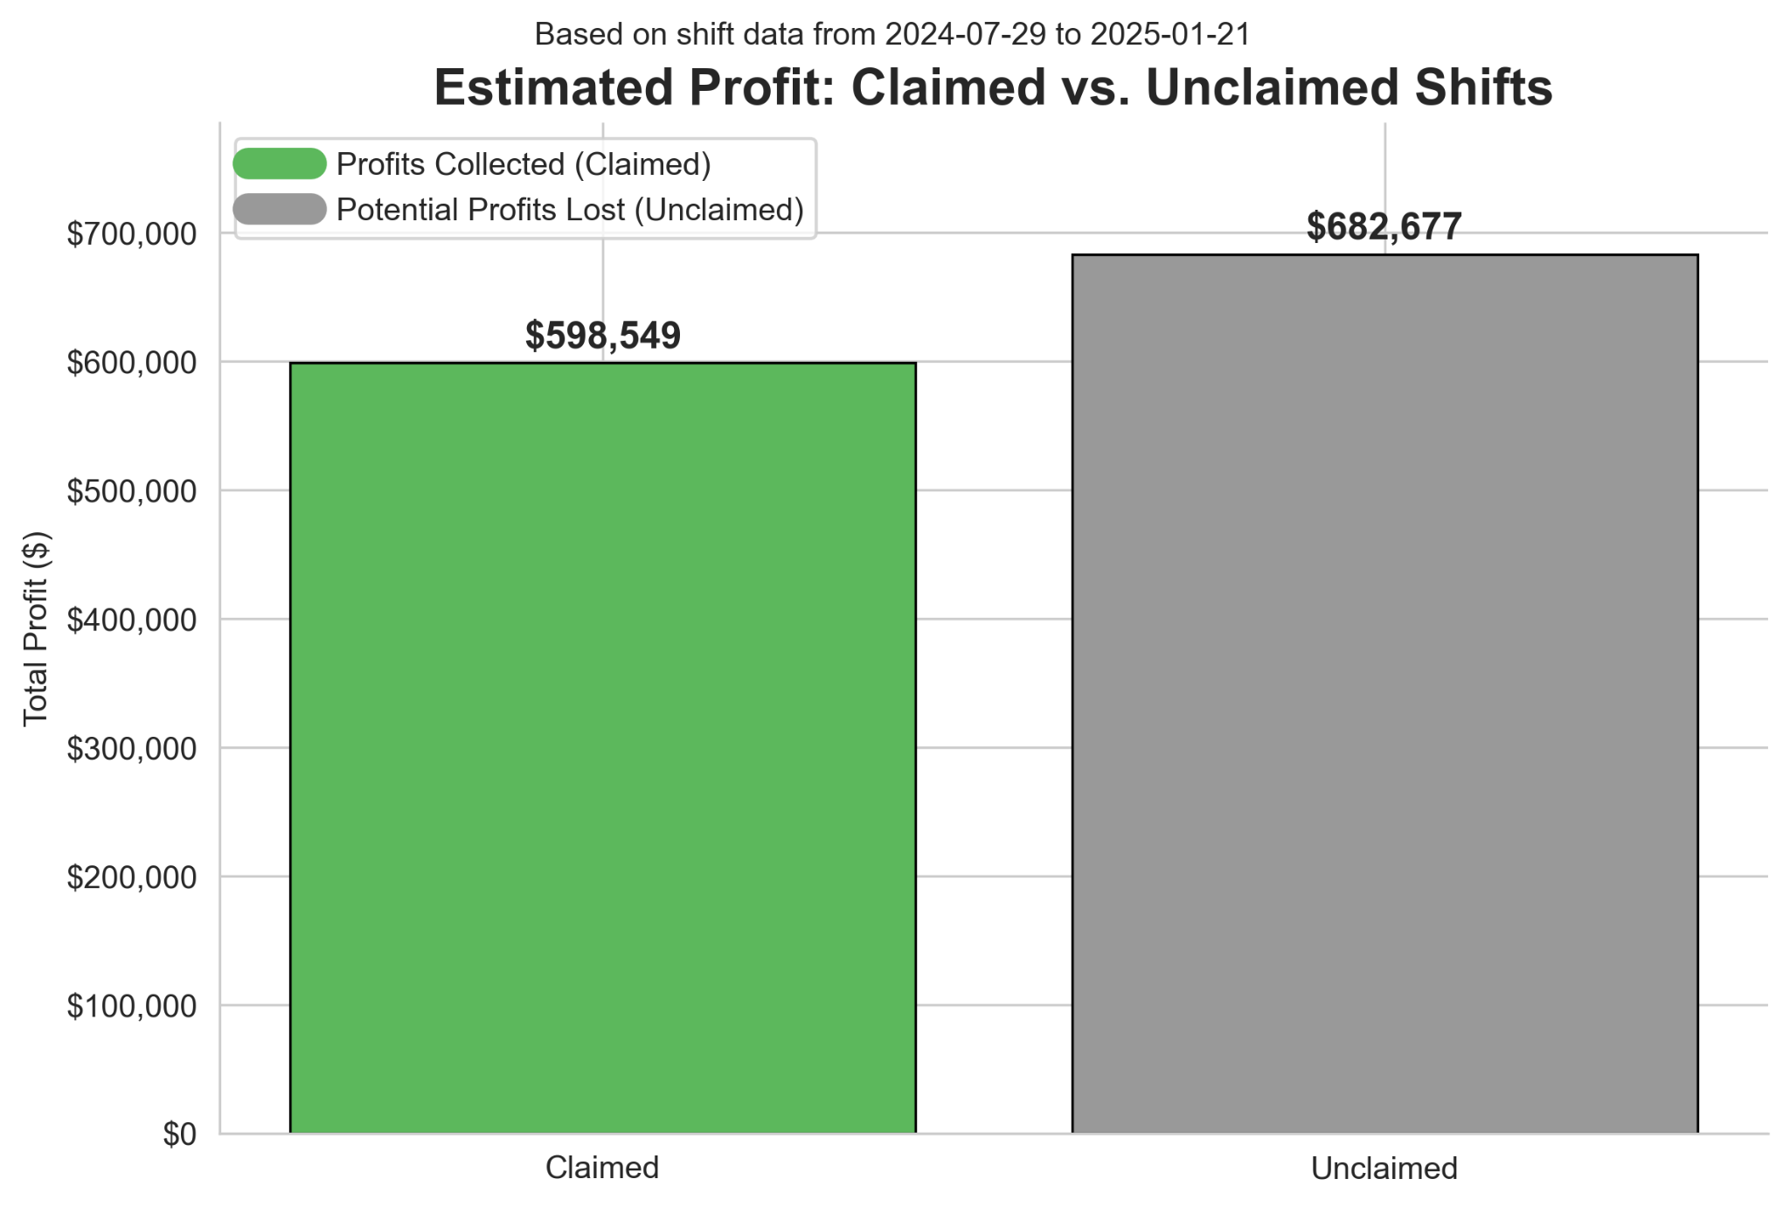
For unclaimed shifts, the revenue we left on the table was almost $100,000 higher than the actual profit from claimed shifts during the analysis period. This significant financial gap showed why it is important to understand what truly drives claim rates.
Plot 1b:
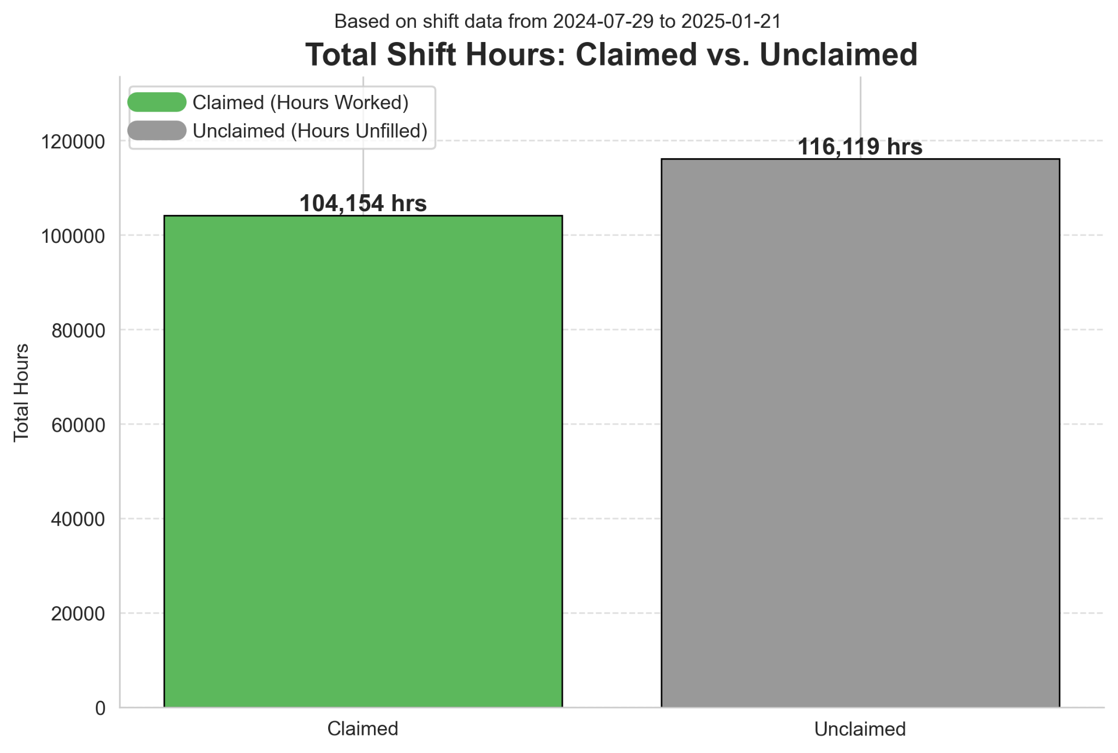
Furthermore, the total number of shift hours that went unfilled was also larger than the number of hours that were worked by over 100,000 hours(plot1b in Appendix). This reveals that the challenge isn't just about profit margins; it's also a critical gap in workforce coverage for facilities and missed earning opportunities for our workers.

Deep Dive: Uncovering Drivers of Shift Claim Likelihood
The Impact of Facility Charge Rates and Worker Pay Rates

I first considered if the financial details of a shift like the facility's CHARGE_RATE and the worker's RATE played a decisive role.
My Process & Analysis:
- Charge Rate Distribution by Facility:
  - I started by looking at the CHARGE_RATE across different WORKPLACE_IDs (see Plot 2 in the Appendix). The rates ranged widely, from $24/hour to $64/hour, with a median of about $33/hour. This showed that RATE couldn’t be judged on its own, since what counts as competitive depends on each facility. These differences likely reflect the location of the healthcare facilities and local cost of living.
Plot 2: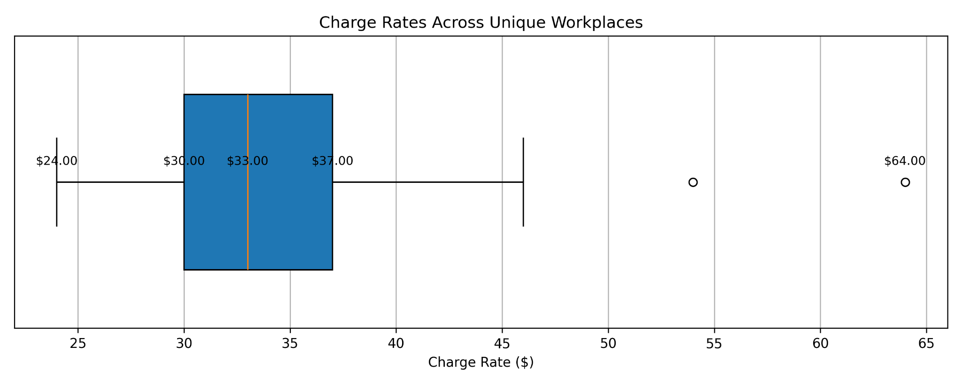
- Pay Rate vs. Charge Rate and Claim Status:
  - Next, I explored if shifts where the RATE met or exceeded the CHARGE_RATE were more likely to be claimed. I created a stacked bar chart (plot3 in Appendix) to compare claimed and unclaimed shifts, differentiating by whether RATE was below or at/above CHARGE_RATE. For unclaimed shifts, I used the highest RATE offered to maintain a conservative perspective.
  - Assumption (for plot3): My analysis here assumes that using the highest RATE for unclaimed shifts truly represents the maximum incentive a facility was willing to offer for that shift, and that this offer was seen and ignored.
Plot 3:
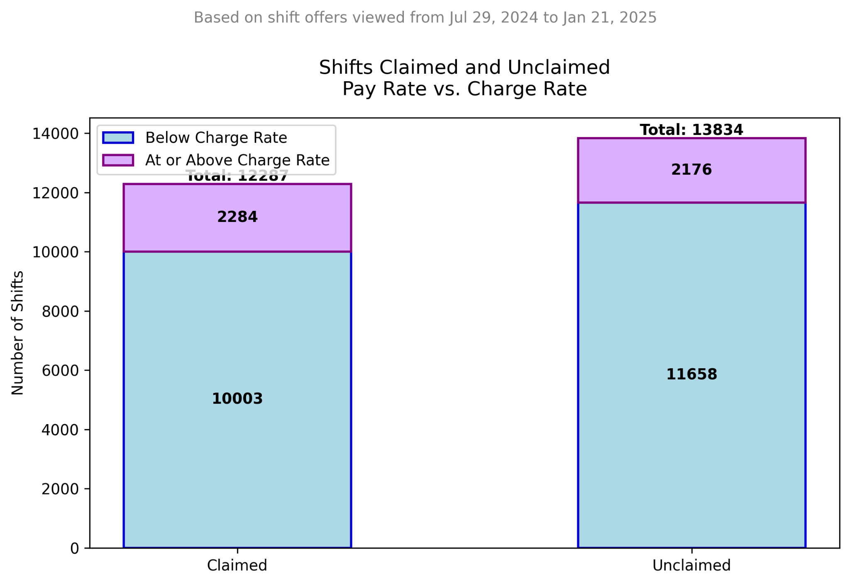
My Finding & Conclusion:
- Interestingly, only about 19% of claimed shifts and 16% of unclaimed shifts had a RATE at or above the CHARGE_RATE. These proportions are surprisingly similar, suggesting that even offering higher pay relative to the facility’s bill rate doesn’t overwhelmingly drive claim rates on its own.
- This proved to me that simply offering pay that matches or exceeds the facility's CHARGE_RATE doesn't guarantee a shift will be claimed. Many shifts are claimed with a healthy margin, and conversely, some go unclaimed even with competitive offers. This clearly suggested other, stronger factors were at play beyond just pricing.

Exploring Shift Characteristics: Duration and Time-of-Day
Since pricing alone wasn't the full story, I shifted my focus to the details of the shifts themselves like timing.
My Process & Analysis:
- Shift Duration and Claim Likelihood:
  - I grouped shifts by their DURATION and CLAIMED status, counting unique SHIFT_IDs. I visualized the total shifts offered versus claimed shifts for each duration, alongside the percentage claimed (plot4a #1 and plot4a #2 in Appendix).
Plot 4a #1:
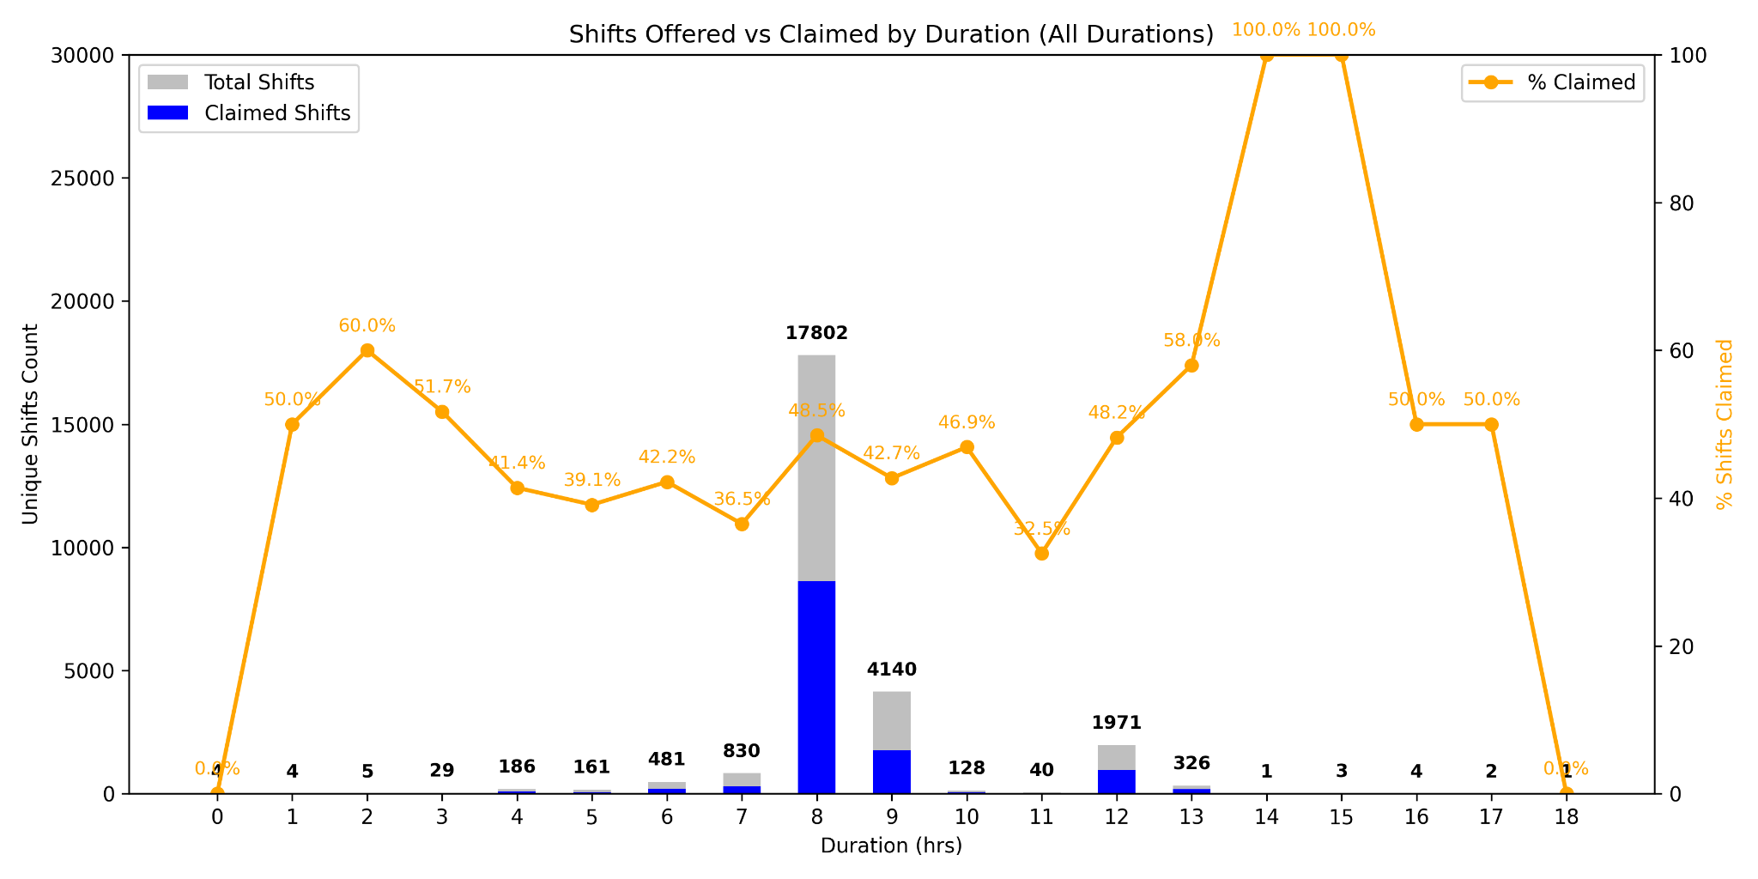
- Important Note: After plotting all durations, there were multiple outliers in claimed percentages due to some durations having very few total shift offers. So in the next plot, I only focused on durations with at least 1000 total shift offers, which was durations 8, 9 and 12.

Plot 4a #2:
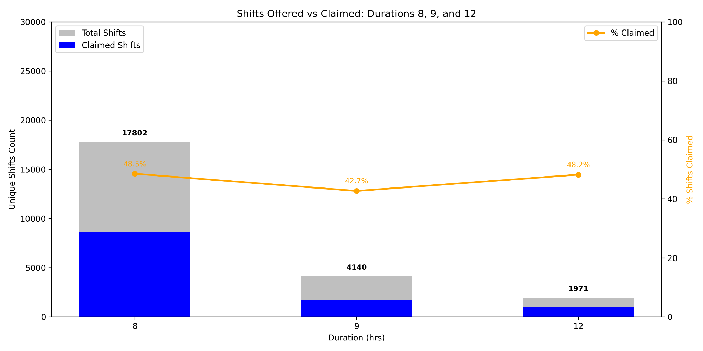
- Profit Margin vs. Duration:
  - I also compared profit margins for claimed versus unclaimed shifts across different durations (plot4b in Appendix).
  - Assumption (for DURATION): I assumed that workers perceive and evaluate shift lengths relatively consistently. While individual preferences exist, I looked for broad patterns that would suggest certain durations are more or less appealing than others.
  - For claimed shifts I calculated profit margin by
    - (charge rate - the pay rate offer when it was claimed) / charge rate * 100%
  - For unclaimed shifts since they don’t have a claimed pay rate offer I calculated profit margin by
    - (charge rate - highest pay rate ever offered) / charge rate * 100%
  - Important Note: This formula was used for all plots when calculating profit margins.

Plot 4b:
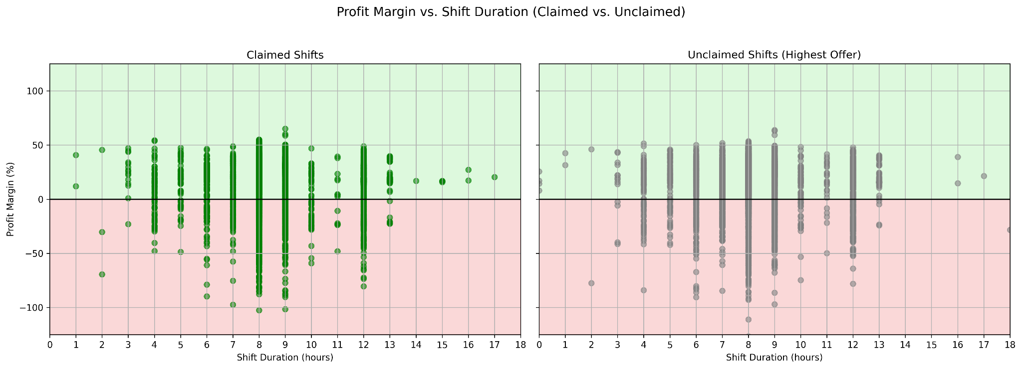

- Profit Margin by Shift Time-of-Day:
  - To see if certain hours were more attractive, I plotted SHIFT_START_AT and SHIFT_END_AT (converted to hour-of-day) against profit margin for both claimed and unclaimed shifts (plot5 in Appendix). The hours of the day that have a asterisks next to it (12am* to 12pm*) represent the next day.
  - Assumption (for plot5): I assumed that converting start and end times to a 36-hour cycle effectively captures a worker's preference for certain parts of the day (morning, afternoon, overnight), and that these preferences are a significant factor in their claiming decision.

Plot 5:
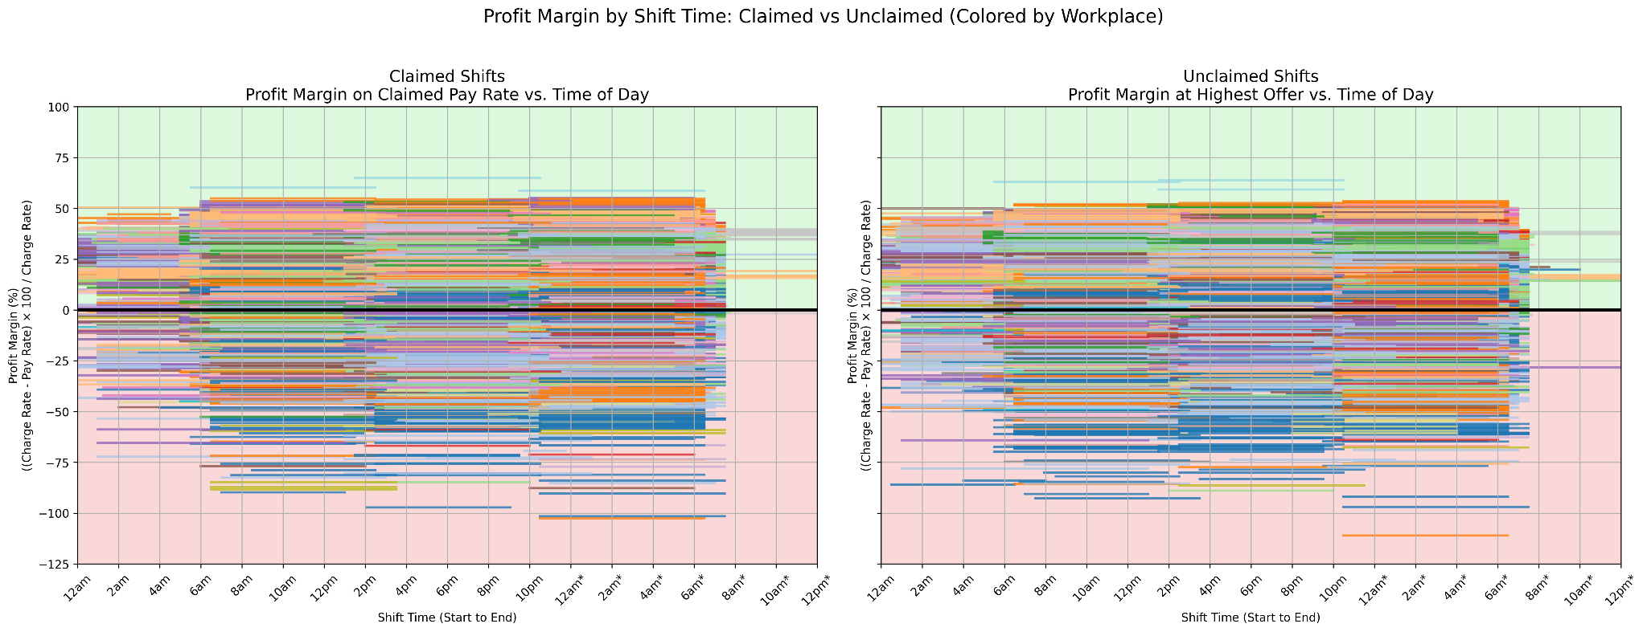
My Finding & Conclusion:
- The most common shift durations (8, 9, and 12 hours) saw the highest volume, but their claim rates (40-50%) weren't significantly different from many other durations. Crucially, profit margins across different durations were strikingly similar for both claimed and unclaimed shifts, showing no clear distinguishing factor.
- Similarly, my visualization of profit margin by time-of-day showed no consistent pattern. For almost every claimed shift at a given time and margin, a corresponding unclaimed shift existed.
- This indicated that DURATION, SHIFT_START_AT and SHIFT_END_AT, even combined with profit margin, were not the primary drivers of whether a shift got claimed.

Investigating External Factors: Calendar Dates and Holidays
My next step was to consider if external factors, like specific calendar dates or major holidays, might influence claim rates.
My Process & Analysis:
- Profit Margin by Calendar Date and Holidays:
  - I plotted SHIFT_START_AT (date only) against profit margin for both claimed and unclaimed shifts from the range of the filtered data in shifts_final.csv which was from September 22nd 2024 to January 20th 2025.
  - I then researched all the national holidays between that time which included Columbus Day, Veterans Day, Thanksgiving, Christmas, New Year’s, Martin Luther King Jr. Day, and added them to the plot (plot6 in Appendix).
  - Assumption: I assumed that major U.S. holidays are universally understood by our worker base as times that might affect their availability or willingness to work, and that these would be visible in the data if they were a strong influencing factor.
Plot 6:
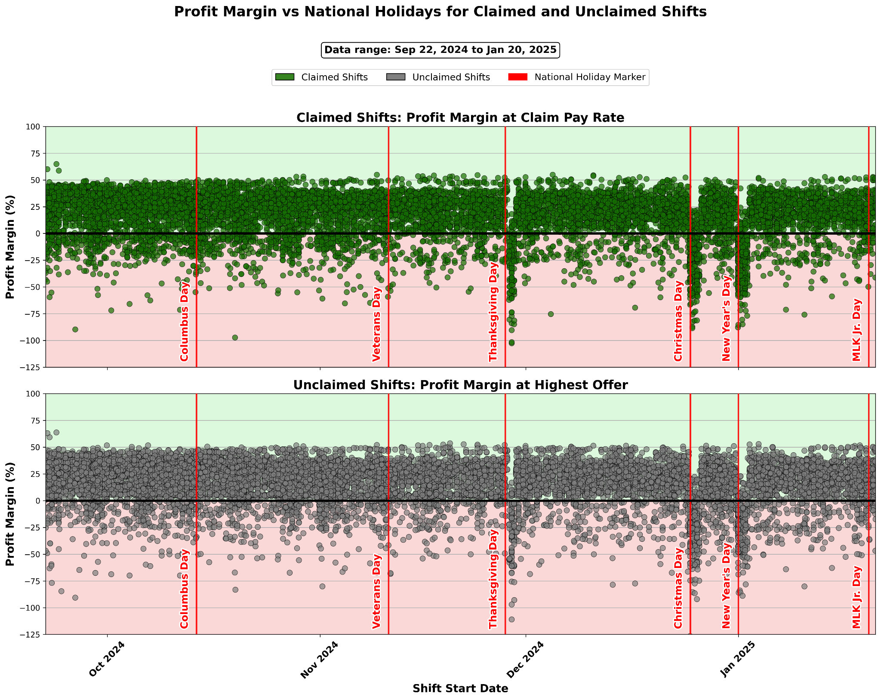
My Finding & Conclusion:
- The visualization didn't show a clear difference in claiming patterns around holidays. While there was a slight increase in negative profit margin shifts around holidays (meaning the RATE was greater than the CHARGE_RATE), these shifts were still claimed and unclaimed inconsistently.
- This suggested that even higher incentives during holidays were not enough on their own to guarantee a shift would be claimed.

Analyzing the Facility’s Role in Posting Timing

After methodically exploring and ruling out direct and external factors from pay rates, shift characteristics, and calendar events, my investigation led me to the timing of the shift posting itself. I wanted to see if a shift was posted relative to its start date and time, defined as post lead time, would affect its chances at being claimed
My Process and Analysis:
- To test this, I calculated the posting_lead_time_hours by finding the difference between SHIFT_START_AT and earliest OFFER_VIEWED_AT for each shift offer. I focused only on positive differences, meaning offers viewed before the shift began. I then binned these hours into 24-hour segments, extending up to 30 days (720 hours) to capture the full spectrum of lead times.
- For each lead time bucket, I counted the unique SHIFT_IDs offered and how many of those were ultimately claimed (CLAIMED == TRUE). Then, I calculated the percentage of claimed shifts within each bucket. To make sure I didn’t have misleading percentages, I ensured all bucket days had at least 50 shifts offered.
Plot 7a:
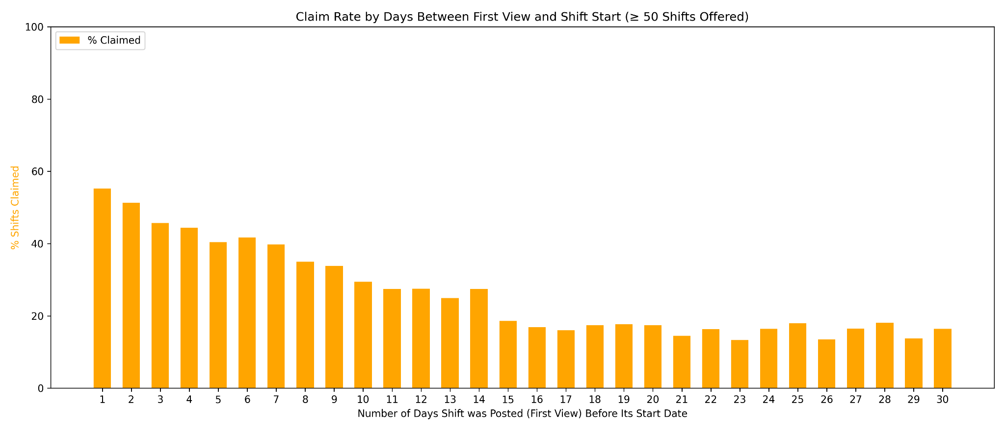
My Finding & Conclusion:
The results were striking and revealed a clear, inverse relationship: shifts posted closer to their start date consistently exhibited significantly higher claim rates. As plot7a (see Appendix) clearly illustrates:
- Shifts with the shortest lead time (0-24 hours before start) had the highest claim rate, hovering around 55%.
- This strong claim rate held steady for shifts posted two to three days in advance, ranging from 45-51%.
- However, claim rates plummeted for shifts posted further out, dropping dramatically to around 14-18% for shifts offered two to four weeks in advance.
This makes sense because if a worker sees a shift for tomorrow, they can quickly check their plans and commit with confidence and full intention to work that shift. But if they see a shift three weeks away, they might hesitate, unsure about family plans, personal obligations, or other work commitments that could pop up.
For example, a caregiver who only knows their kids’ school activities for the next week is far more comfortable booking a shift this weekend than risking a commitment three weeks out.
From the facility’s perspective, they might think that posting shifts very early will increase their chances of getting the shift filled. But what may be happening instead is that older postings might get buried under a flood of newer shifts in the app feed. Workers might not see these older postings again when they’re actually available to book, leaving them effectively invisible even if they were posted early.
To ensure this finding wasn't just a hidden effect of skewed pay for last-minute shifts, I conducted a further analysis. I compared the average profit margins across different posting lead time buckets for both claimed and unclaimed shifts (plot7b in Appendix).

Plot 7b:
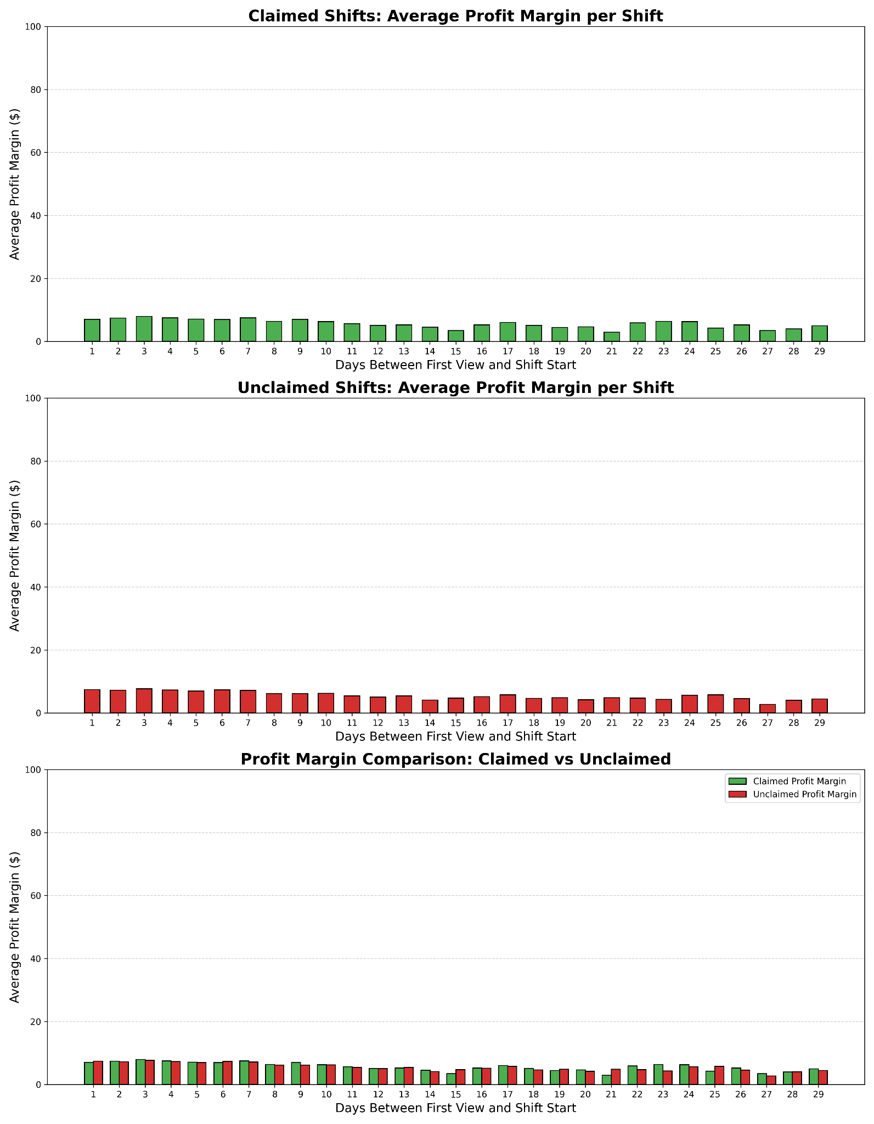
The results showed that average profit margins were fairly consistent across all lead time buckets and virtually identical between claimed and unclaimed shifts. This confirms that posting lead time, not higher pay or profit margin, is the primary factor behind the observed claim rate patterns. This is a key distinction, because it gives us an insight into improving claim rates without having to impact our profit margins.

Interpretation and Implications:
This finding is incredibly valuable because it points directly to an actionable lever for Clipboard Health and our facilities. Unlike tweaking pay rates, which can impact profitability, optimizing posting lead time is a simple operational adjustment that can significantly boost fill rates.
- For Operational Improvements: We can advise facilities to strategically time their shift postings. If they have a shift that needs filling two weeks out, the facility might think posting it earlier will generate more views. But actually they should hold off on posting it until a few days prior.
- Hypothesized Reasons: The underlying reasons likely include:
  - Worker Certainty: Healthcare professionals often have dynamic schedules. If they commit to a shift weeks in advance, but realize later they will not be able to make it, they will have to cancel or even not show up. But if they know they are free the next day and see a new shift that is scheduled then, they will be more likely to commit to it.
  - Visibility/Discovery: Offers posted earlier might get less visibility in the feed that is always being updated with new shifts.

Limitations & Future Questions
While this analysis uncovered a strong signal regarding posting lead time, it's important to acknowledge some limitations:
- The given dataset covers a specific period (July 2024 - January 2025) and my filtered dataset in shifts_final.csv only ranges from September 22nd 2024 to January 20th 2025 so it might not fully capture seasonal variations or long-term trends in worker behavior.
- My profit margin calculation for unclaimed shifts uses the highest offered pay rate, which is a conservative estimate but doesn't account for whether other, even higher offers for the same shift might also have gone unclaimed.
- We only have data on viewed offers. There might be shifts that were never viewed, or offers that were never sent, which could also represent missed opportunities.
  - Assumption: I assumed that if a viewed offer lacks a claimed_at timestamp, it was definitively not claimed, rather than due to a data capture error or a claim that was later deleted but not fully reflected in the provided columns.
- Since I wasn’t given data on the exact time a shift was officially posted, I used the timestamp of the first recorded view for each shift as a proxy for when the shift was initially posted and getting traction.
- I also wasn’t sure about how the user interface was designed for healthcare workers using the Clipboard Health app.
  - Assumption: Since I was not provided with details on how the Clipboard Health app specifically displays shifts to workers, I assumed the shift feed is ordered with the most recently posted shifts appearing at the top, sorted by start date. As new shifts are posted, these could gradually push older, unclaimed postings further down the feed, reducing their visibility and making them less likely to be claimed.

Future Questions and Potential Next Steps:
- Finding the Best Time to Post Shifts:
  - Can we figure out the ideal lead time for different kinds of shifts, how long they last, or even specific facilities? There might be a “sweet spot” where the timing matches workers’ availability and makes it easier to fill shifts.
- Improving How Shifts Are Shown in the App:
  - How does the app’s design and user experience affect a worker’s choice to accept shifts with different lead times?
  - Can we create features that better highlight urgent shifts or ones with special perks, so workers notice them more and decide faster?
- Predicting Which Shifts Will Get Filled:
  - Could we build a model that predicts the chance of a shift being claimed based on its lead time and other important factors?
  - This would help facilities post shifts in the best way to get them filled quickly.
- Facility-Specific Patterns:
  - Let’s look closer at individual facilities. Are there some places that always have trouble filling shifts, no matter how early they post?
  - If so, it might point to bigger problems like the location, reputation, or special requirements of those shifts that need to be addressed.

Conclusion
This analysis clearly shows that offering competitive pay isn't the only factor determining if a shift gets claimed. Instead, the timing of the shift offer relative to its start date emerges as a critical, and often underutilized, leverage point. Our workers clearly prefer shifts posted closer to their start time, valuing immediate availability and schedule certainty.
Understanding this dynamic gives Clipboard Health a powerful tool. By strategically guiding facilities on optimal posting lead times, we can significantly boost shift claim rates, reduce unfilled hours, and ultimately make our marketplace far more efficient and profitable. This insight opens the door for actionable product and operational strategies that can drive substantial positive impact for both health facilities and professionals on our platform.

Appendix
Visualizations (Plots)

Plot 1a: Estimated Profit for Claimed vs. Unclaimed Shifts

Plot 1b: Total Shift Hours for Claimed vs. Unclaimed Shifts

Plot 2: Charge Rate Distribution by Facility (WORKPLACE_ID)

Plot 3: Worker Pay Rate vs. Facility Charge Rate and Claim Status

Plot 4a #1: Shift Duration and Claim Likelihood (All Durations)

Plot 4a #2: Shift Duration and Claim Likelihood (Top 3 Durations)

Plot 4b: Profit Margin by Shift Duration

Plot 5: Profit Margin by Shift Time-of-Day

Plot 6: Profit Margin by Calendar Date and Holidays

Plot 7a: Posting Lead Time and Claim Likelihood

Plot 7b: Profit Margin by Posting Lead Time

